Terraform Challenge-01

Write a code using Terraform that deploys and achieves the following:-
- Create an EC2 Instance on AWS Cloud using the below-mentioned ubuntu AMI and instance_type. Or, (You can use of your choice as well) ami = "ami-0461b1436c9b3c1a3" instance_type = "t3.micro"

Step 1. Create a project folder
mkdir ec2
cd ec2
Create a file called: main.tf

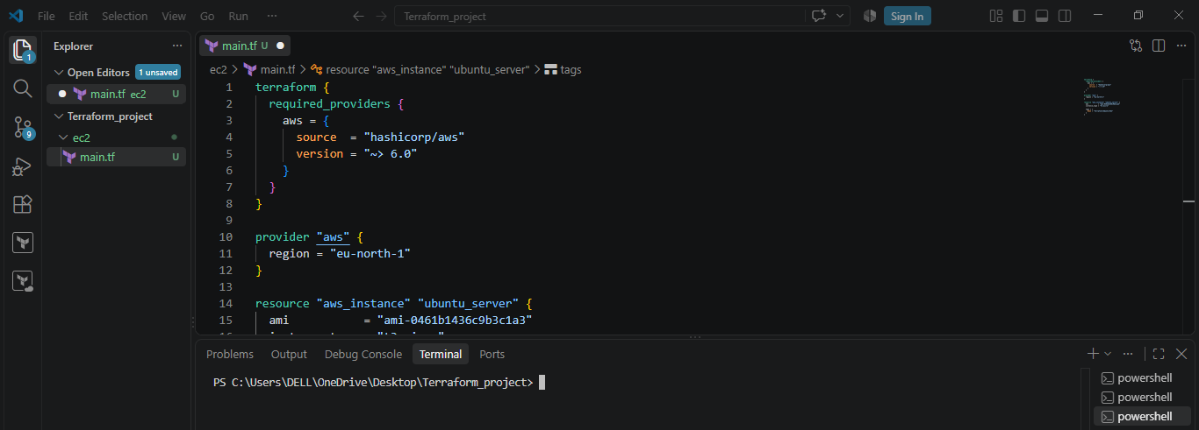

Step 2: main.tf

Write script inmain.tf file.

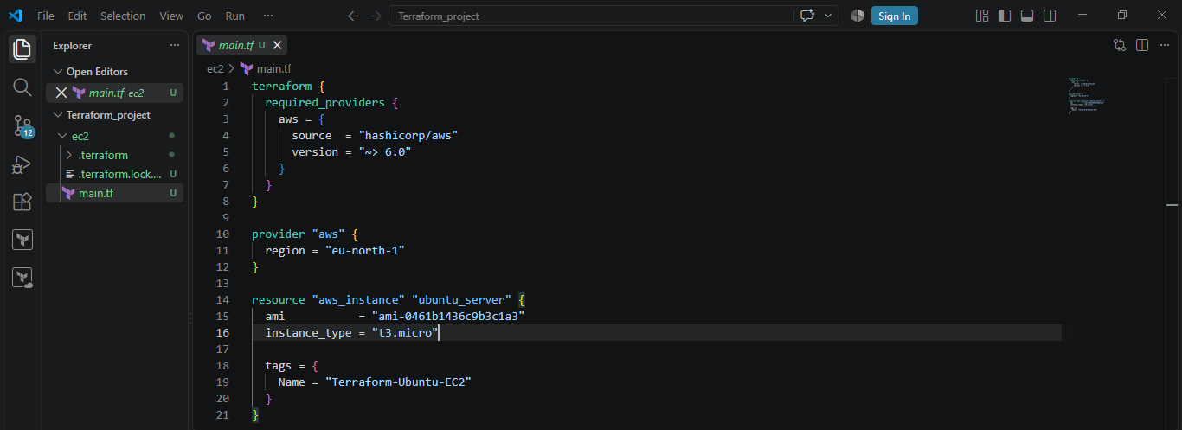

3. Initialize Terraform
Run: terraform init
This downloads the AWS provider and prepares the Terraform working directory.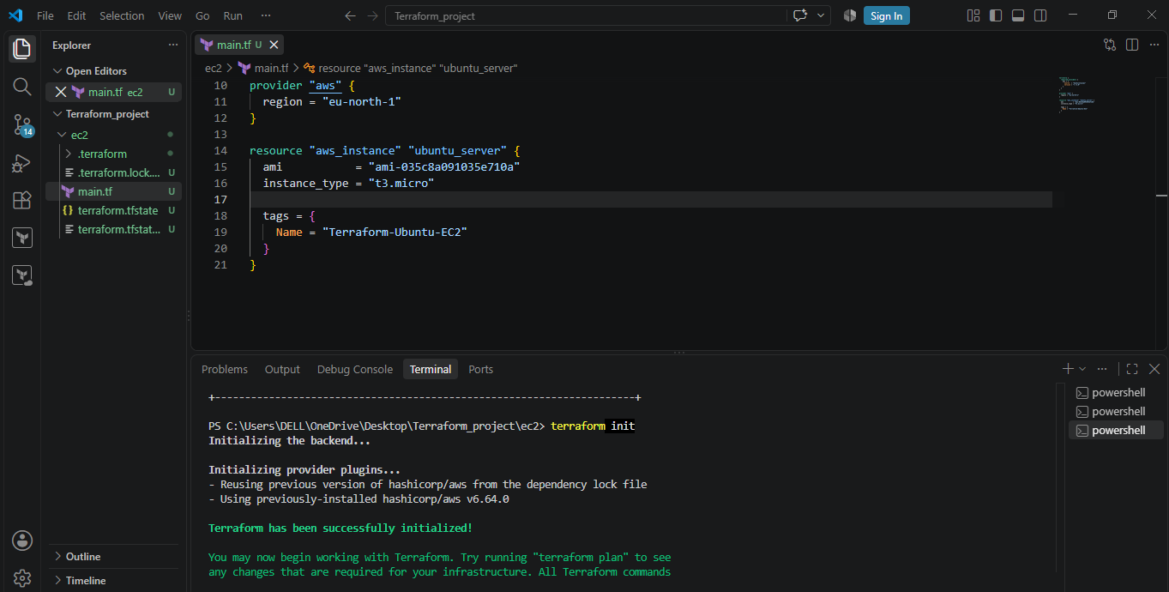
Since our assignment is to use an Ubuntu AMI, let's find an Ubuntu AMI that exists in your region.
As we want to stay with eu-north-1 (Stockholm), run this command in terminal:
aws ec2 describe-images --owners 099720109477 --filters "Name=name,Values=ubuntu/images/hvm-ssd-gp3/ubuntu-noble-24.04-amd64-server-*" "Name=state,Values=available" --query "Images | sort_by(@, &CreationDate)[-1].[ImageId,Name]" --output table --region eu-north-1
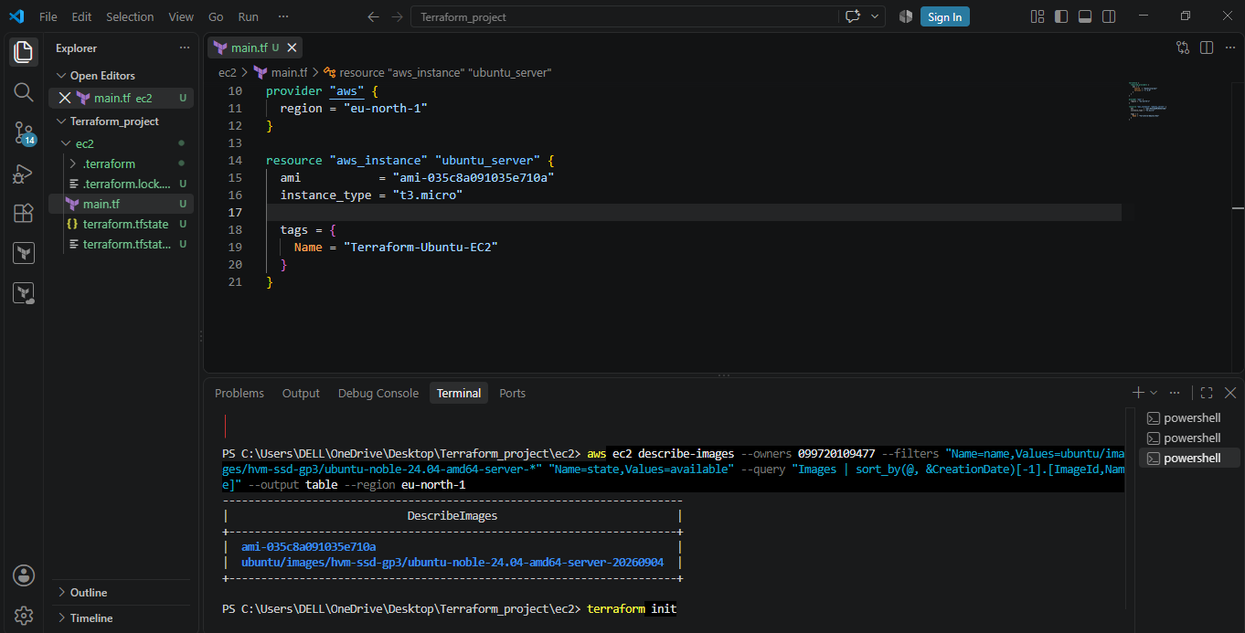
Then run terraform apply:
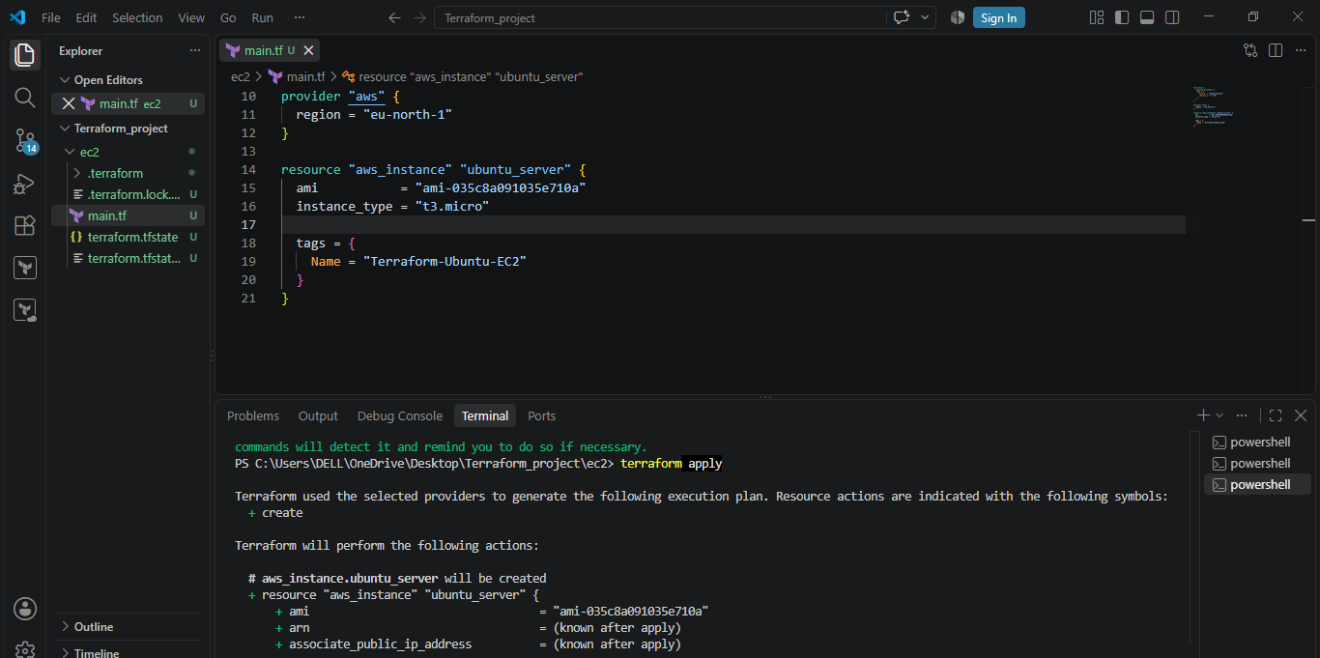

Verify the instance in AWS:
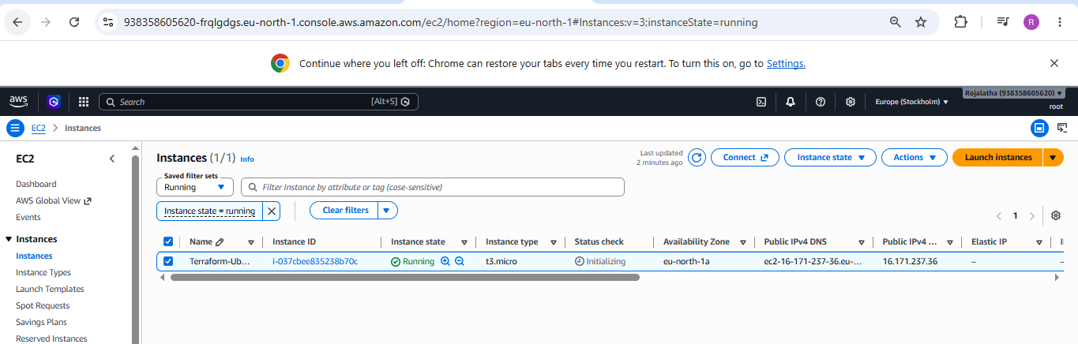

2. Install a web server on the same EC2 Instance. The web server should listen on port 8080.

Step 1: update main.tf with the following code:
terraform {
required_providers {
aws = {
source = "hashicorp/aws"
version = "~> 6.0"
}
}
}

provider "aws" {
region = "eu-north-1"
}

data "aws_ami" "ubuntu" {
most_recent = true
owners = ["099720109477"]

filter {
name = "name"
values = ["ubuntu/images/hvm-ssd-gp3/ubuntu-noble-24.04-amd64-server-*"]
}

filter {
name = "state"
values = ["available"]
}

filter {
name = "architecture"
values = ["x86_64"]
}
}

resource "aws_security_group" "web_sg" {
name = "terraform-web-sg"
description = "Allow SSH and HTTP 8080"

ingress {
description = "SSH"
from_port = 22
to_port = 22
protocol = "tcp"
cidr_blocks = ["0.0.0.0/0"]
}

ingress {
description = "Web Server 8080"
from_port = 8080
to_port = 8080
protocol = "tcp"
cidr_blocks = ["0.0.0.0/0"]
}

egress {
from_port = 0
to_port = 0
protocol = "-1"
cidr_blocks = ["0.0.0.0/0"]
}

tags = {
Name = "Terraform-Web-SG"
}
}

resource "aws_instance" "ubuntu_server" {
ami = data.aws_ami.ubuntu.id
instance_type = "t3.micro"

security_groups = [aws_security_group.web_sg.name]

user_data = <<-EOF
#!/bin/bash

apt-get update -y
apt-get install -y apache2

sed -i 's/^Listen 80$/Listen 8080/' /etc/apache2/ports.conf
sed -i 's/:80>/:8080>/' /etc/apache2/sites-available/000-default.conf

systemctl restart apache2
systemctl enable apache2

echo "<h1>Terraform EC2 Web Server</h1>" > /var/www/html/index.html
EOF

tags = {
Name = "Terraform-Ubuntu-WebServer"
}
}

The above code will:
1. Creates a Security Group
ingress {
from_port = 8080
to_port = 8080
protocol = "tcp"
cidr_blocks = ["0.0.0.0/0"]
}
This allows traffic to reach your EC2 instance on:
Port 8080

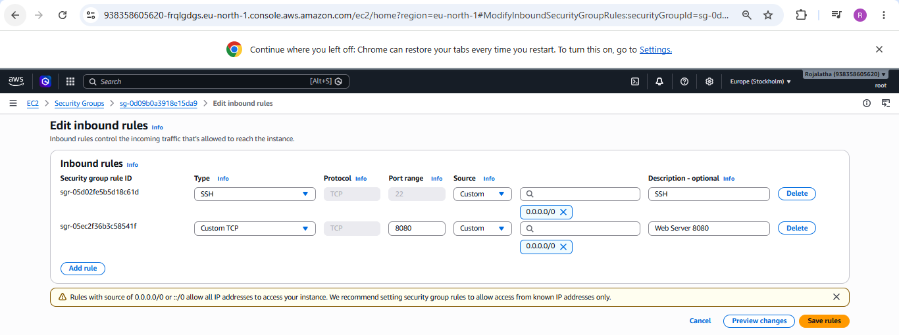
2. Installs Apache automatically
The user_data script runs when the EC2 instance starts:
apt-get update -y
apt-get install -y apache2
So you don't have to manually SSH into the server and install Apache.

3. Changes Apache from port 80 to port 8080
sed -i 's/^Listen 80$/Listen 8080/' /etc/apache2/ports.conf
and:
sed -i 's/:80>/:8080>/' /etc/apache2/sites-available/000-default.conf
Therefore Apache will listen on:
8080

Apply the changes
Run terraform plan

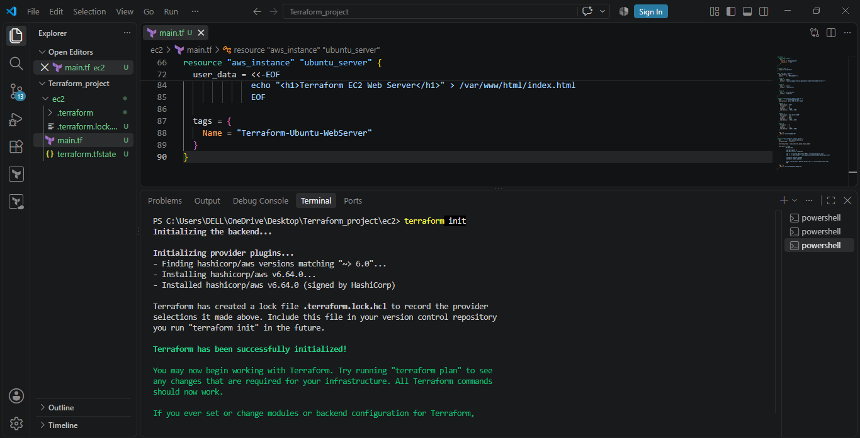

Then: terraform apply
Enter:
Yes
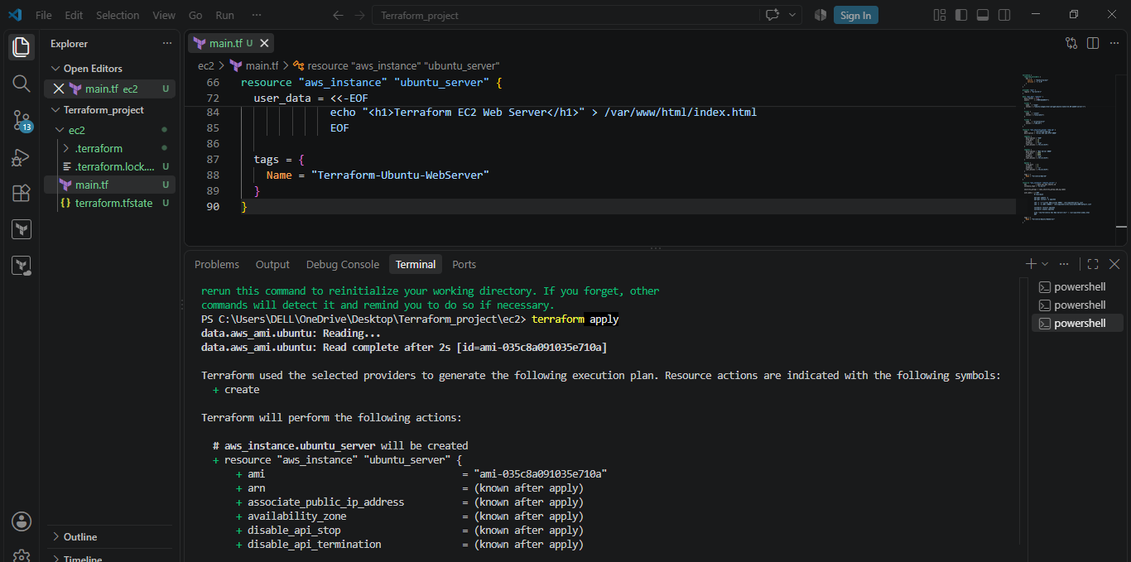

Get the EC2 public IP
You can find it in:
AWS Console → EC2 → Instances → Your instance → Public IPv4 address
Open your browser and enter:
http://ip:8080
You should see:
Terraform EC2 Web Server

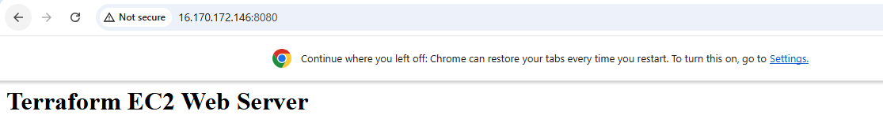
3. Create a Docker-compose file for the project:https://github.com/betawins/cricbuzz-docker-hello-world.gitand point it to port 8000.

Step 1: Clone the project
git clone https://github.com/betawins/cricbuzz-docker-hello-world.git
cd cricbuzz-docker-hello-world

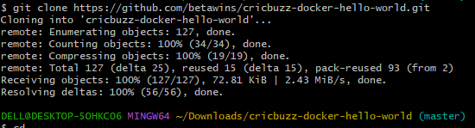

Step 2: Create the Compose file
vi docker-compose.yml
Put this inside:
docker-compose.yml
services:
cricbuzz:
build: .
ports:
- "8000:8080"

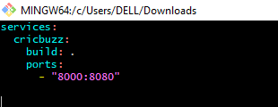

Step 3: Start the application
docker compose up -d --build
Check:
docker compose ps
You should see a port mapping similar to:
0.0.0.0:8000->8080/tcp

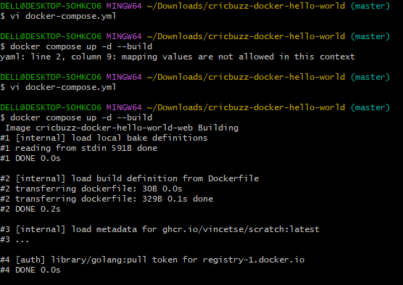

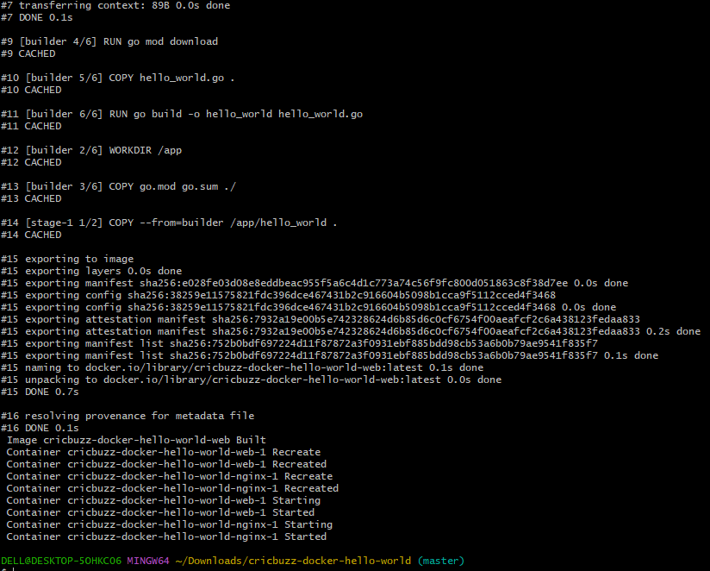

Step 4: Test it
From the EC2 server:
curl http://localhost:8000
The repository documents / as returning HTTP 200 with Hello, World!.
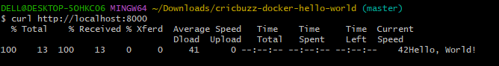
From your browser:

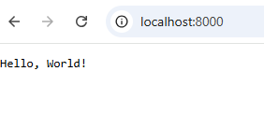

4. Make the web server point to the above service so that 8080 returns the response from the Docker service.

Step 1 — Change docker-compose.yml

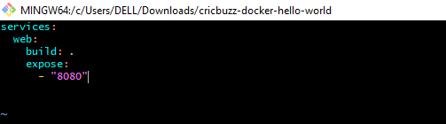

Step 2 — Create Nginx configuration
Create:
vi nginx.conf
Put:
events {}

http {
server {
listen 8080;

location / {
proxy_pass http://web:8080;
}
}
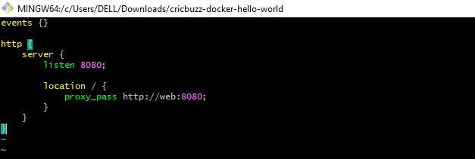

Here: web:8080
means: Send the request to the Docker Compose service named web on port 8080.

Step 3 — Add Nginx to Compose
Change docker-compose.yml to:
services:
web:
build: .
expose:
- "8080"

nginx:
image: nginx:alpine
ports:
- "8080:8080"
volumes:
- ./nginx.conf:/etc/nginx/nginx.conf:ro
depends_on:
- web
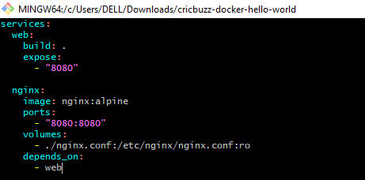

Step 4 — Restart everything
Run: docker compose down
Then: docker compose up -d
Check: docker ps
You should see something similar to:
nginx 0.0.0.0:8080->8080/tcp
web 8080/tcp

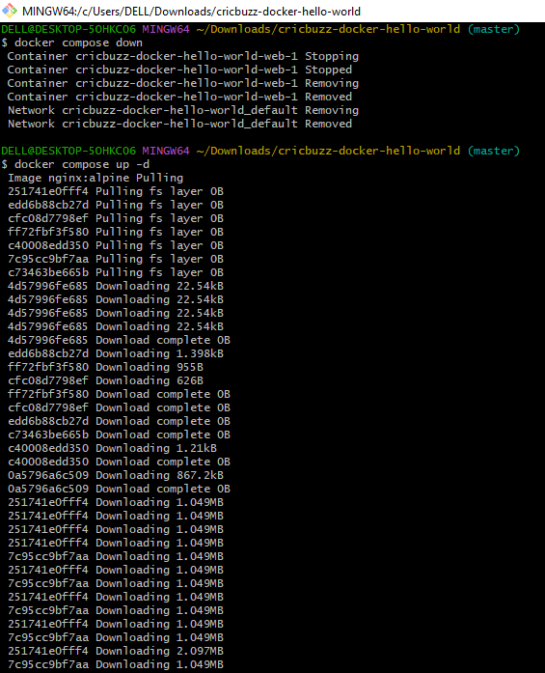

Step 5 — Test
Run:
curl http://localhost:8080
The response should now come from your Cricbuzz application through Nginx.
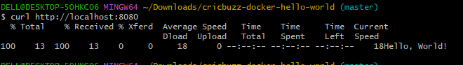
You can also open:
http://localhost:8080 in your browser.

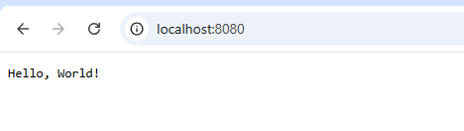

5. Configure to Save the Logs in the location /var/log/cb.log

Write the Log rotate configuration for the above file
Create Terraform Project
Create a Terraform directory.
Example:
mkdir C:\Users\HP\Desktop\Terraform\ec2
Move into the directory:
cd C:\Users\HP\Desktop\Terraform\ec2
Create a file:
main.tf
The Terraform configuration will be stored in this file.

4. Configure AWS Provider
The AWS provider tells Terraform to use AWS.
terraform {
required_providers {
aws = {
source = "hashicorp/aws"
version = "~> 6.0"
}
}
}

provider "aws" {
region = "us-east-1"
}

5. Create Security Group
The security group allows:
- SSH → Port 22
- Nginx → Port 8080
- Outbound traffic → All
resource "aws_security_group" "cricbuzz_sg" {
name = "cricbuzz-nginx-sg"
description = "Allow SSH and Nginx"

ingress {
description = "SSH"
from_port = 22
to_port = 22
protocol = "tcp"
cidr_blocks = ["0.0.0.0/0"]
}

ingress {
description = "Nginx"
from_port = 8080
to_port = 8080
protocol = "tcp"
cidr_blocks = ["0.0.0.0/0"]
}

egress {
from_port = 0
to_port = 0
protocol = "-1"
cidr_blocks = ["0.0.0.0/0"]
}
}
For a real production environment, SSH access should normally be restricted to trusted IP addresses rather than 0.0.0.0/0.

6. Create IAM Role
The EC2 instance needs permission to access the private ECR repository.
Create an IAM role:
resource "aws_iam_role" "cricbuzz_ec2_role" {
name = "cricbuzz-ec2-ecr-role"

assume_role_policy = jsonencode({
Version = "2012-10-17"

Statement = [
{
Effect = "Allow"

Principal = {
Service = "ec2.amazonaws.com"
}

Action = "sts:AssumeRole"
}
]
})
}
Why do we need IAM?
The EC2 instance needs permission to:
Login to ECR
↓
Pull Docker image
↓
Run Docker container

7. Attach ECR Read-Only Policy
Attach the AWS-managed ECR read-only policy:
resource "aws_iam_role_policy_attachment" "ecr_read_only" {
role = aws_iam_role.cricbuzz_ec2_role.name

policy_arn = "arn:aws:iam::aws:policy/AmazonEC2ContainerRegistryReadOnly"
}
This allows the EC2 instance to read and pull images from ECR.

8. Create IAM Instance Profile
The instance profile allows the IAM role to be attached to EC2.
resource "aws_iam_instance_profile" "cricbuzz_instance_profile" {
name = "cricbuzz-ec2-instance-profile"

role = aws_iam_role.cricbuzz_ec2_role.name
}

9. Create EC2 Instance
Create the EC2 instance:
resource "aws_instance" "cricbuzz" {

ami = "ami-0332d564d76dbd8d6"
instance_type = "t3.micro"
key_name = "Terraform-key"

vpc_security_group_ids = [
aws_security_group.cricbuzz_sg.id
]

iam_instance_profile = aws_iam_instance_profile.cricbuzz_instance_profile.name
The IAM instance profile connects the EC2 instance to the IAM role.

10. Install Required Software Using User Data
Terraform user_data automatically executes commands when the EC2 instance starts for the first time.
We install:
- Docker
- Nginx
- Logrotate
- AWS CLI
dnf update -y

dnf install -y docker nginx logrotateawscli

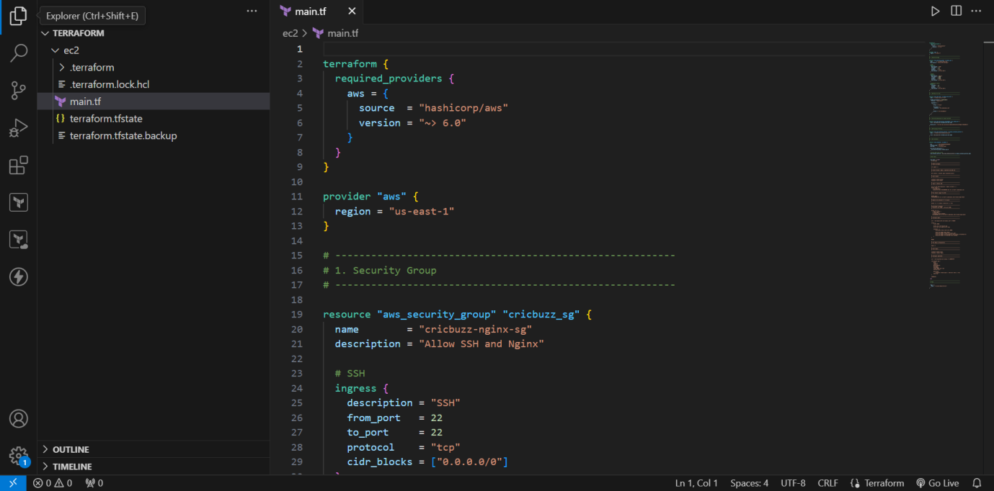
Start Docker
Enable Docker to start automatically:
systemctl enable docker
systemctl start docker
Verify:
systemctl status docker
Expected:
active (running)
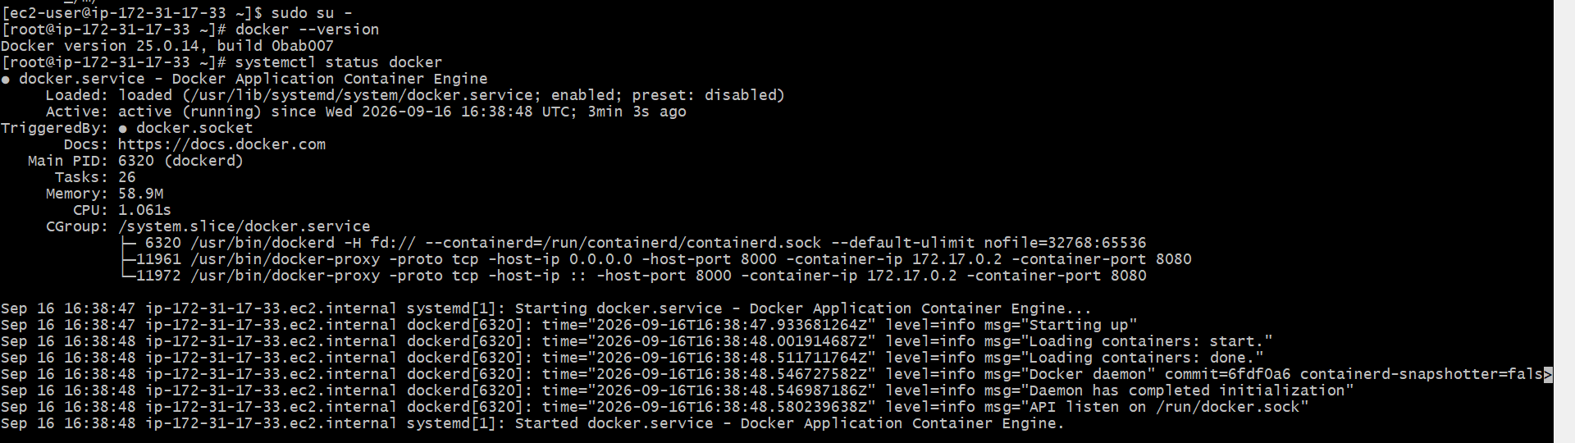
Login to Amazon ECR
The EC2 instance uses its IAM role to authenticate with ECR.
awsecr get-login-password --region us-east-1 | \
docker login \
--username AWS \
--password-stdin 934140896884.dkr.ecr.us-east-1.amazonaws.com
Pull Docker Image from ECR
Pull the Cricbuzz application image:
docker pull \
934140896884.dkr.ecr.us-east-1.amazonaws.com/cricbuzz-app:latest
Verify:
docker images
The ECR image should be displayed.

14. Run Docker Container
Run the application:
docker run -d \
--name cricbuzz \
-p 8000:8080 \
--restart unless-stopped \
934140896884.dkr.ecr.us-east-1.amazonaws.com/cricbuzz-app:latest
Port Mapping
EC2 Host
Port 8000
|
v
Docker Container
Port 8080
Check the container:
docker ps
Expected:
0.0.0.0:8000->8080/tcp
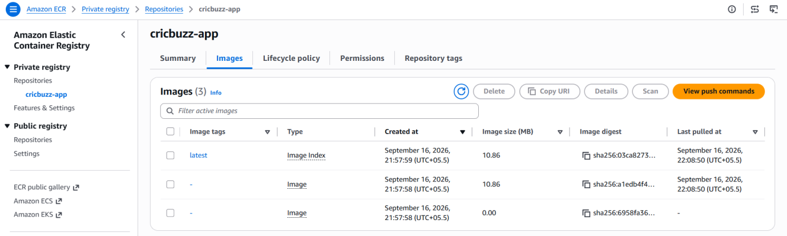
Test Docker Application
Run:
curl http://localhost:8000
Expected output:
Hello, World!
This confirms that the Docker application is working.
Configure Nginx
Create the Nginx configuration:
/etc/nginx/conf.d/cricbuzz.conf
Configuration:
server {
listen 8080;

access_log /var/log/cb.log;
error_log /var/log/cb-error.log;

location / {
proxy_pass http://127.0.0.1:8000;

proxy_set_header Host $host;
proxy_set_header X-Real-IP $remote_addr;
proxy_set_header X-Forwarded-For $proxy_add_x_forwarded_for;
proxy_set_header X-Forwarded-Proto $scheme;
}
}
Configure Logrotate
Create:
/etc/logrotate.d/cricbuzz
Configuration:
/var/log/cb.log {
daily
rotate 7
compress
delaycompress
missingok
notifempty
create 0640 root root
sharedscripts

postrotate
systemctl reload nginx > /dev/null 2>&1 || true
endscript
}
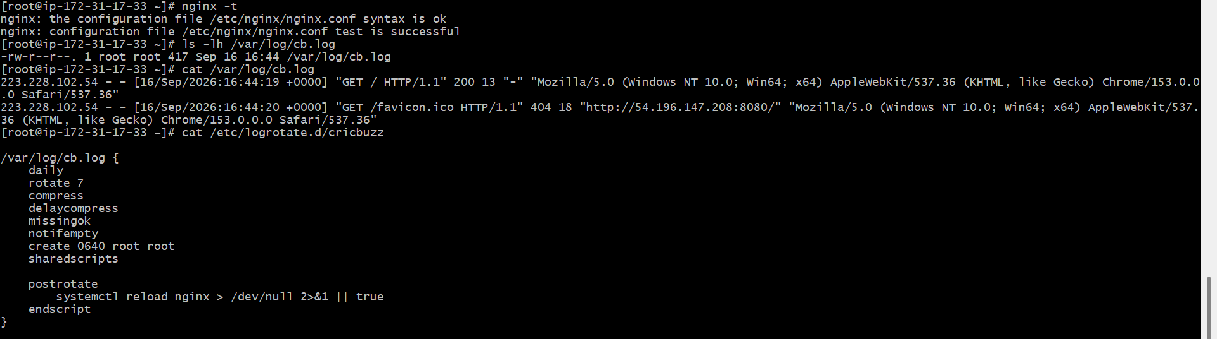
Start Nginx
Enable Nginx:
systemctl enable nginx
Start/restart Nginx:
systemctl restart nginx
Check status:
systemctl status nginx
Expected:
active (running)

20. Test Nginx
Run:
curl http://localhost:8080
Expected:
Hello, World!
This confirms:
Nginx → Docker → Application
is working.
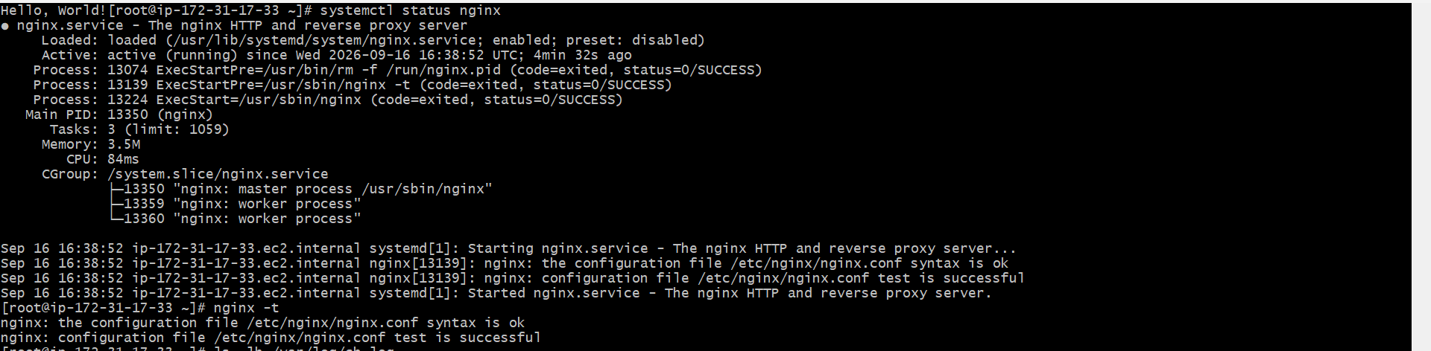
Verify IAM from EC2
After connecting to the EC2 instance, you can verify that AWS credentials are being provided through the IAM role.
Run:
awssts get-caller-identity
You should get output containing an ARN similar to:
Arn: arn:aws:sts::934140896884:assumed-role/cricbuzz-ec2-ecr-role/...
The important part is:
cricbuzz-ec2-ecr-role
This confirms that the EC2 instance is using the IAM Role.
